Harry Laing Book Order form
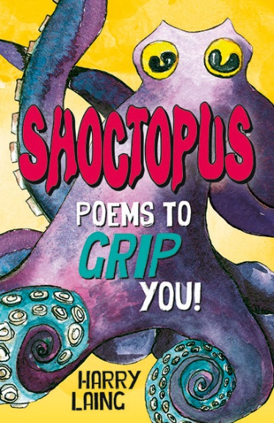
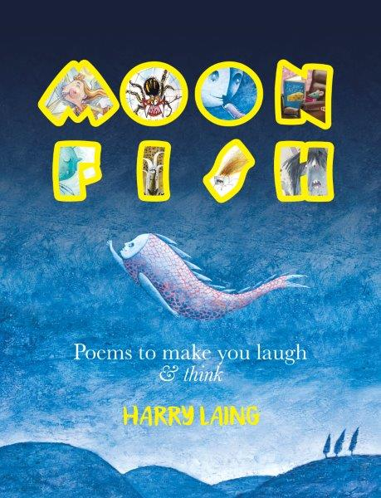

Book Title | Price | Quantity
Shoctopus  MoonFish | $15.00  $15.00

Total cost:
Name: _____________________________________
Class: __________________________________
Who would you like Harry to sign the book for?__________________________________
_________________________________________________________________________

Payment via Internet Banking/Direct deposit
Name: Harry Laing
BSB: 633000
ACC: 152859203
Please reference with your name.

